**Code body**

Base case find—loe: 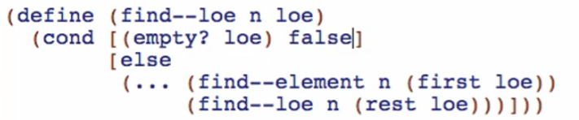

find—element:

* 2 cases
  + Find right away
  + We don’t find it right away

Using if:

Question:

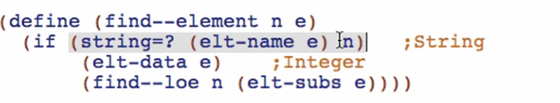

True answer: (find right away)

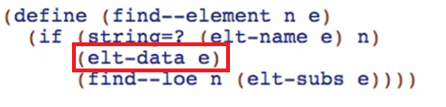

* Return the data

False answer: (don’t find right away)

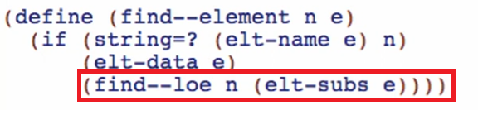

* Keep looking in the list!

find—loe:

adding example:

